**CONVERT REQUIREMENTS TO TEST**

**You need to be on “Requirement Tree View”**

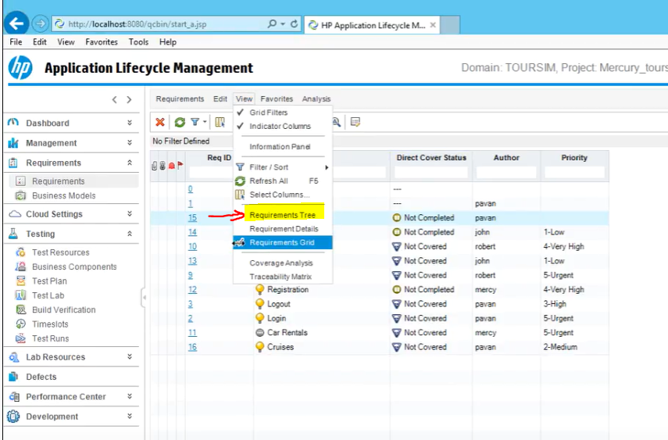

**Select the requirements you want to convert**

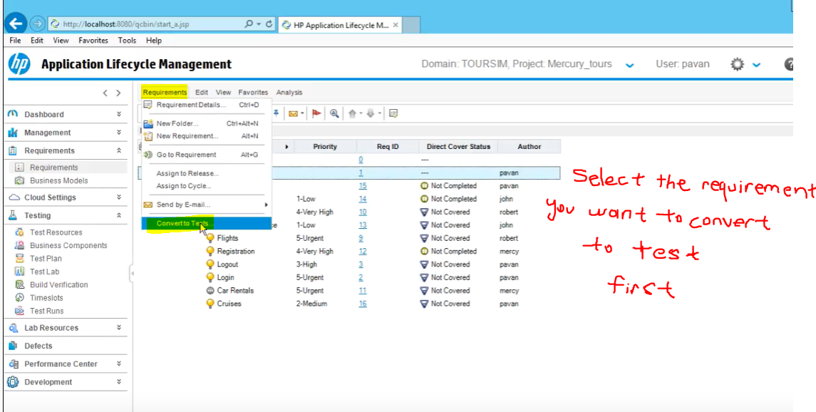

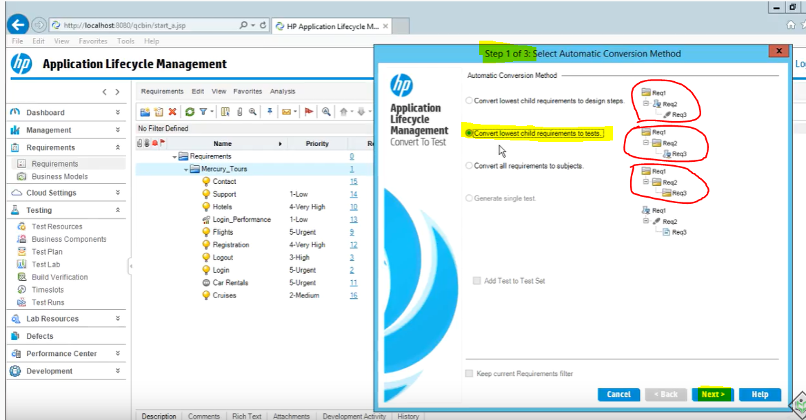

**Next**



**Next**

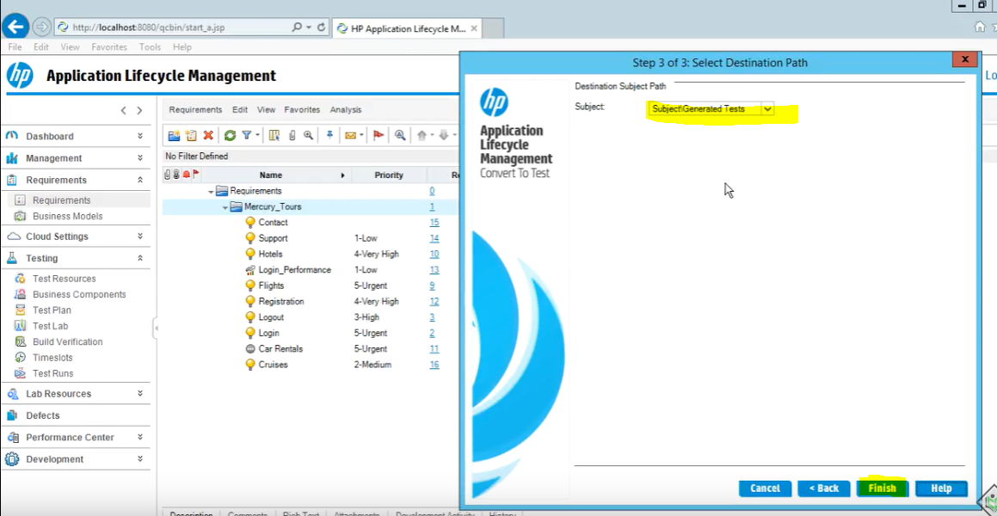

**In order to view these generated test cases,**

**You need to go to test plan.**

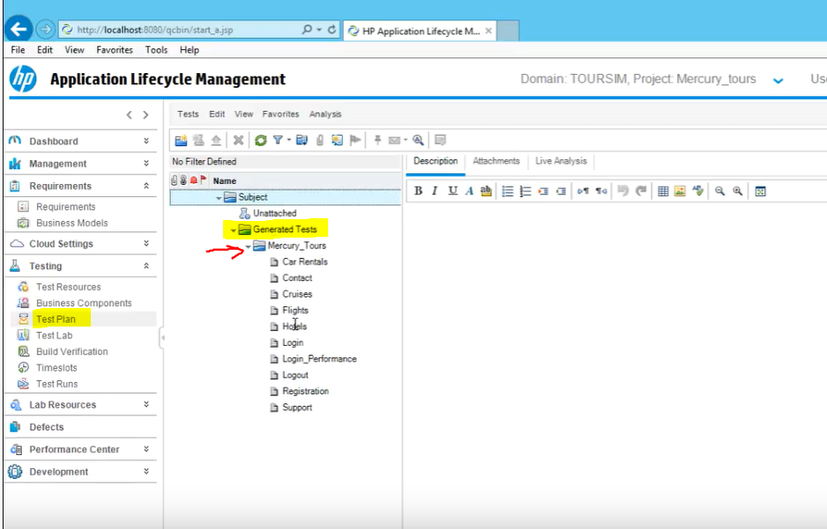

**When you click on a test, you will be able to see test details**

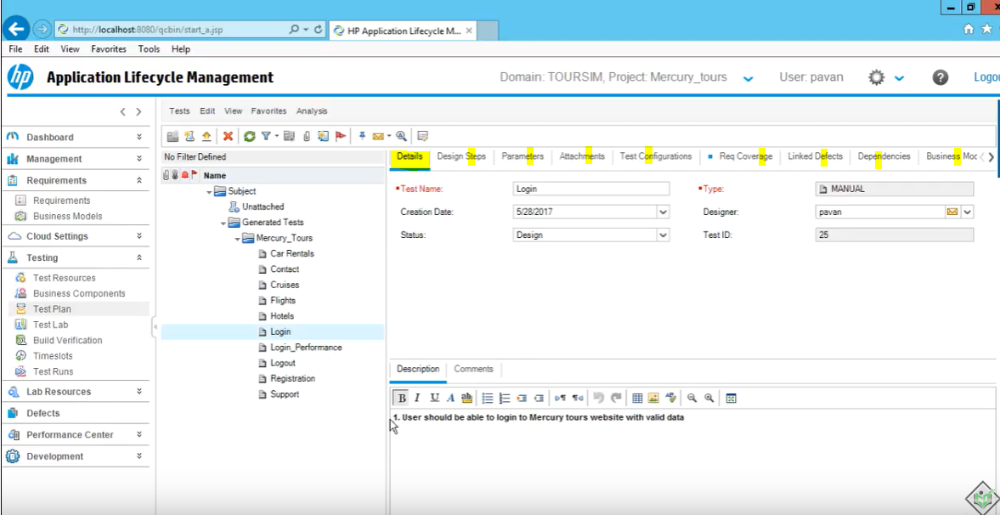

**Direct Cover Status before converting tests**



**After converting requirements to tests**

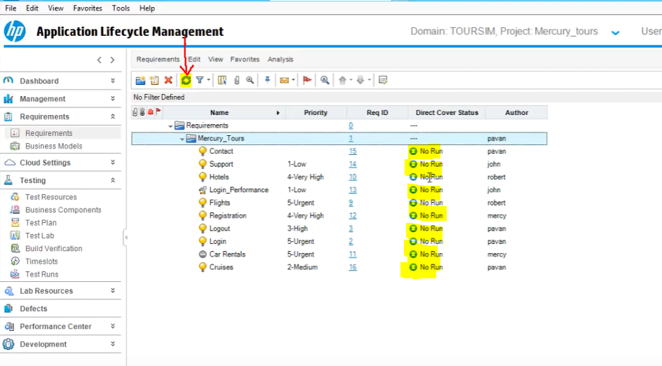

**No Run means test case is assigned but not executed yet**

**The reason why you convert requirements to test cases is because you will not be missing or skipping a test.**